Жеребцов К. А. ИВТб - 21 ДЗ

Задание: Синтезировать автомат на RS триггерах, заданный следующей таблицей переходов.

|  |  |  |  |  |  |  |
| --- | --- | --- | --- | --- | --- | --- |
|  | a1 | a2 | a3 | a4 | a5 | a6 |
| z1 | a2 | - | a5 | a2 | a5 | a5 |
| z2 | a1 | a4 | a1 | a6 | - | a1 |
| z3 | a6 | a1 | - | a3 | a4 | a3 |

Для кодирования 6 состояний необходимо 3 ЭП

|  |  |  |
| --- | --- | --- |
| 1 | 2 | 9 |
| 1 | 6 | 10 |
| 2 | 4 | 9 |
| 2 | 1 | 9 |
| 3 | 5 | 6 |
| 3 | 1 | 8 |
| 4 | 2 | 9 |
| 4 | 6 | 10 |
| 4 | 3 | 8 |
| 5 | 4 | 8 |
| 6 | 5 | 8 |
| 6 | 1 | 10 |
| 6 | 3 | 8 |

|  |  |
| --- | --- |
| a1 | 5 |
| a2 | 4 |
| a3 | 3 |
| a4 | 5 |
| a5 | 3 |
| a6 | 5 |

M =

|  |  |  |
| --- | --- | --- |
| 1 | 6 | 10 |
| 6 | 1 | 10 |
| 4 | 6 | 10 |
| 1 | 2 | 9 |
| 2 | 4 | 9 |
| 2 | 1 | 9 |
| 4 | 2 | 9 |
| 3 | 1 | 8 |
| 4 | 3 | 8 |
| 5 | 4 | 8 |
| 6 | 5 | 8 |
| 6 | 3 | 8 |
| 3 | 5 | 6 |

M =

a1 = 000 a6 = 001

|  |  |
| --- | --- |
| 1 | 6 |
| 6 | 1 |
| 4 | 6 |
| 1 | 2 |
| 2 | 4 |
| 2 | 1 |
| 4 | 2 |
| 3 | 1 |
| 4 | 3 |
| 5 | 4 |
| 6 | 5 |
| 6 | 3 |
| 3 | 5 |

M` =

|  |  |
| --- | --- |
| 4 | 6 |
| 2 | 4 |
| 4 | 2 |
| 4 | 3 |
| 5 | 4 |

M4 =

B4 = {6} = {001} C16 = {011, 101}

W011 = |011 – 001|2 = 1

W101 = |101 – 001|2 = 1

a4 = 101

|  |  |
| --- | --- |
| 1 | 6 |
| 6 | 1 |
| 4 | 6 |
| 1 | 2 |
| 2 | 4 |
| 2 | 1 |
| 4 | 2 |
| 3 | 1 |
| 4 | 3 |
| 5 | 4 |
| 6 | 5 |
| 6 | 3 |
| 3 | 5 |

M`` =

|  |  |
| --- | --- |
| 1 | 2 |
| 2 | 4 |
| 2 | 1 |
| 4 | 2 |

M2 =

B2 = {1, 4} = {000, 101} C11 = {100, 010} C14 = {111, 100}

D12 = {010, 100, 111}

W010 = 2 * |010 – 000|2 + 2 * |010 – 101|2 = 2 * 1 + 2 * 3 = 8

W100 = 2 * |100 – 000|2 + 2 * |100 – 101|2 = 2 * 1 + 2 * 1 = 4

W111 = 2 * |111 – 000|2 + 2 * |111 – 101|2 = 2 * 3 + 2 * 1 = 8

a2 = 100

|  |  |
| --- | --- |
| 1 | 6 |
| 6 | 1 |
| 4 | 6 |
| 1 | 2 |
| 2 | 4 |
| 2 | 1 |
| 4 | 2 |
| 3 | 1 |
| 4 | 3 |
| 5 | 4 |
| 6 | 5 |
| 6 | 3 |
| 3 | 5 |

M``` =

|  |  |
| --- | --- |
| 3 | 1 |
| 4 | 3 |
| 6 | 3 |
| 3 | 5 |

M3 =

B3 = {1, 4, 6} = {000, 101, 001}

C11 = {010} C14 = {111} C16 = {011}

D13 = {010, 011, 111}

W010 = |010 – 000|2 + |010 – 101|2 + |010 – 001|2 = 1 + 3 + 2 = 6

W011 = |011 – 000|2 + |011 – 101|2 + |011 – 001|2 = 2 + 2 + 1 = 5

W111 = |111 – 000|2 + |111 – 101|2 + |111 – 001|2 = 3 + 1 + 2 = 6

a3 = 011

|  |  |
| --- | --- |
| 1 | 6 |
| 6 | 1 |
| 4 | 6 |
| 1 | 2 |
| 2 | 4 |
| 2 | 1 |
| 4 | 2 |
| 3 | 1 |
| 4 | 3 |
| 5 | 4 |
| 6 | 5 |
| 6 | 3 |
| 3 | 5 |

M(4) =

|  |  |
| --- | --- |
| 5 | 4 |
| 6 | 5 |
| 3 | 5 |

M5 =

B5 = {3, 4, 6} = {011, 101, 001}

C13 = {111, 010} C14 = {111} C16 = {}

D13 = {010, 111}

W010 = |010 – 011|2 + |010 – 101|2 + |010 – 001|2 = 1 + 3 + 2 = 6

W111 = |111 – 011|2 + |111 – 101|2 + |111 – 001|2 = 1 + 1 + 2 = 4

a5 = 111

|  |  |  |  |
| --- | --- | --- | --- |
|  | τ3 | τ3 | τ3 |
| a1 | 0 | 0 | 0 |
| a2 | 1 | 0 | 0 |
| a3 | 0 | 1 | 1 |
| a4 | 1 | 0 | 1 |
| a5 | 1 | 1 | 1 |
| a6 | 0 | 0 | 1 |

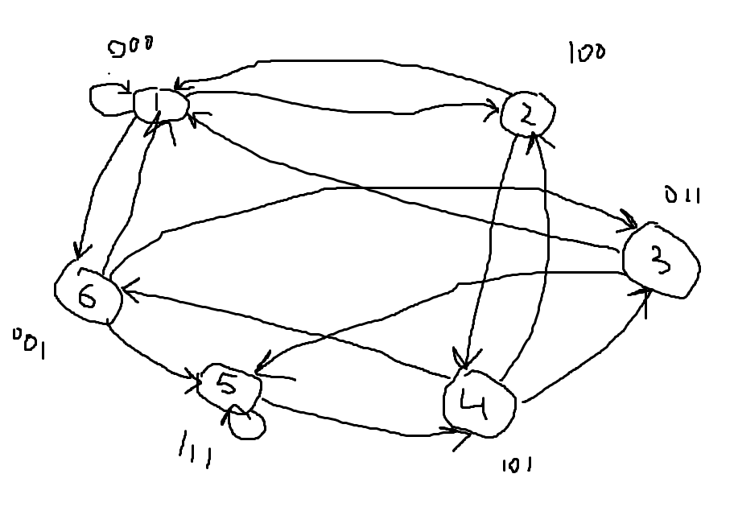

W = 16 – количество переключений памяти

P = 13 - количество переходов

K = W/P = 1,23 < 1,5